THE PHOTOELECTRIC EFFECT

QUESTION TO BE INVESTIGATED
In a photoelectric system, what is the relationship between incident light intensity, incident light frequency, and stopping voltage?

INTRODUCTION
The photoelectric effect is one of the three basic means by which radiation interacts with matter, the other two being the Compton scattering and particle-antiparticle pair production. It occurs when photons of energies greater than one or two eV fall on the surface of a metal or, in fact, on matter in any form, and then interact with that material’s electrons sometimes producing a current. These ejected electrons are often referred to as photoelectrons. The characteristic equation for this interaction, the so-called Einstein photoelectric equation, is simply a statement of conservation of energy for the process. In the initial state one has a photon with energy hυ, υ being the frequency of the incident light, and an electron in a bound state with energy -Fb. In the final state there is the electron with energy Ee. In the case of a metal target, the electron may be energized at some depth below the surface and may lose some of its energy before it escapes. The spectrum of electron energies is therefore a continuum. The conservation of energy equation thus gives the maximum energy electrons may have.

(1)

In a photocell, the electrons are collected by an electrode placed near the photosensitive surface. If this electrode is biased by a negative voltage -V, then only those electrons with Ee > V will have enough energy to reach the electrode and be collected. Thus by increasing V until all electrons are repelled (i.e. no current) the magnitude of Ee can be determined. This voltage is called the critical or stopping voltage Vc and Eq. (1) can be re-written as,
(2)

Thus, a graph of Vc versus the frequency υ will have a slope equal to h/e. The object of this experiment is to determine this ratio by measurements of Vc for different values of frequency.

EXPERIMENT
There are two aspects of this experiment that present problems: the production of monochromatic light and the measurement of very small currents. We will use a mercury lamp to produce spectral lines and then filter out those that we don't want. The filters are of the "low-pass" variety, which attenuate light with wavelengths up to a certain limit and pass everything with longer wavelengths (or lower energy). A typical filter response curve might look like the curve shown in Figure 1. Lines A, B and C are completely rejected, and lines E and F are totally passed by the filter. Line D is partially passed and might represent the line may be considered in the measurement. The fact that lines E and F are present in the transmitted spectrum presents no problem because they produce lower energy electrons than line D so they will already be completely repressed by the time the voltage is increased to the vicinity of Vc for line D. It would be nice to have a filter so that line C was completely eliminated while line D was not attenuated at all. Usually, though, this is not possible and some compromise must be reached. A list of the filters suitable for the mercury spectrum, and a discussion of the compromises involved, are included as an appendix.
Figure 1. Wavelength response of a filter. What would it mean if line C were only 99.99% rejected instead of the depicted 100% rejection? Remember, energy is inversely proportional to wavelength.

An example of a plot of collected current versus retarding voltage is shown in
Fig. 2. The problem is to accurately determine the point Vc at which the curve just

Figure 2. A sample curve of data. Notice V_{c} is located at the point where the curve no longer fits to a straight line.

begins to depart from the linear region to the left of Vc. To do this it will be necessary to take sufficient data in the linear region to determine the straight line. Then it will be necessary to take rather accurate data in vicinity of Vc. A Keithly autoranging digital picoammeter will do nicely for the current readings and a digital voltmeter works well for the voltage measurements. Increments at least 0.05 volts should be taken near Vc.
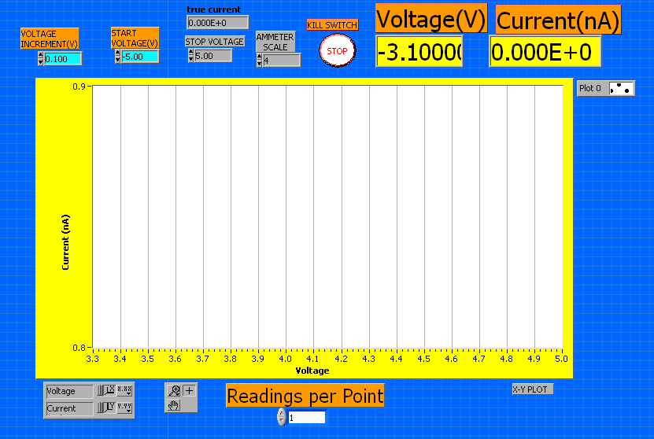
Figure 3. The LabVIEW interface for this experiment. From right to left: The step size, the starting voltage, the stop voltage (where the experiment will terminate, not the stopping voltage referenced herein), and the Ammeter scale. The lower the scale number the finer the scale. However, 0 corresponds to auto-ranging, which you do not want. The VI will prompt you before beginning each experiment to specify a location for the data to be saved.

PROCEDURE: Frequency vs. Stopping Voltage
In this section you will address the question concerning the relationship between photon energy and photoelectron energy. Based on the discussion above what do you think this relationship will be?
Select a filter from the list in the appendix and place it in the filter holder in the photocell assembly. Make sure no light can get in and turn off the room lights. Apply a voltage that for which you expect to see current from the photoelectric effect. Stop the light getting into the photocell and observe that the current falls significantly. Do not go further until this test is successful. Apply a negative voltage that is certainly below Vc. Observe the current and the dark current obtained by obstructing the photocell entrance with your hand. The two should be essentially the same. If not, this is an indication that the light entering the photocell is too bright. It is being reflected off the photosensitive surface onto the collecting electrode where spurious photoemission is taking place. Reduce the light intensity by placing a limiting aperture over the exit from the mercury source.

Take data for four or more lines selected with filters discussed in the appendix. For a given line the intensity should be as high as possible without inducing the effect described above. Adjust or remove the light-limiting aperture accordingly. Even with maximal intensity the currents that must be measured are very small, on the order of
10-9 or 10-10 amps. The surface resistance of the photocell base insulation and the socket insulation is on the order of 109 W. Thus there will be a leakage current on the same order as the currents you are trying to measure. These leakage currents are the source of the sloping, negative line below Vc. Note: In order to get a good value for h/e it is desirable to take a large number (20) of measurements close to the critical voltage.

Intensity vs. Stopping Voltage
In this section you will address the question concerning the relationship between intensity and stopping voltage. Intensity may be defined as the number of photons incident on a surface per unit time. While holding frequency constant, how do you think a change in intensity will effect the stopping voltage? How will it effect the current observed?
Using whichever filter you choose, take data with the lamp pressed directly up to the photocell assembly, then at some distance away, and then at a much further distance away. By moving the lamp backwards you are reducing the amount photons incident on its surface because it is essentially becoming a smaller and smaller target. Take these three data sets for at least two different filters. Then make a claim concerning the relationship between stopping voltage, frequency, and intensity. Support your claims as necessary.

REPORT
Include a sample graph of I vs. V showing your fits. Create a plot of V_{c} vs. frequency. Report your method for determining V_{c} from each plot and your statistical support for this method. Report the slope of this line with its corresponding error. Does it match the scientific community’s accepted value for h/e? From the intercept of your fit, what else can you determine?
Do not forget to report claims and evidence mentioned in the pervious section as well.

APPENDIX
The filters discussed below will allow determination of critical potentials using light from a mercury spectrum with the following wavelengths: 366.0, (390.6, 404.7), 434.0, (491.6), 546.1 and 578.3, all in nm. There are several strong lines below 350 nm that cannot be used because ordinary glass, used in the lenses and the bulb in which the photocell is housed, does not pass light with these wavelengths.

366.0 Use filter 4-94 (#48) or 5-59 (#51, 52 or 53). This a complex "line"
where the wavelengths in nm are given followed by their relative intensities. Filter 4-94 has a transmission of 27% for these lines while eliminating 334.1 (0.05%). Filter 5-59 attenuates the 334.1 better (<0.01%) but passes only 10% of the desired wavelength.

390.6, 404.7 The 390.6 line is fairly weak (≈25). There are two medium intensity lines at 404.7.
There is no filter which passes the 404.7 but eliminates the 390.6. However, filter 3-75 (#31,32 or 33) eliminates the 366.0 (<0.04%) and provides some enhancement of the 404.7:
so the 404.7 should contribute about 30 times more than the 309.6 in transmitted intensity.

434.0 This is a triplet with (unfortunately) the strongest component at the longest wavelength:
Use filter 3-74 (#30) which passes 60% of these lines with the following attenuations:

491.6 This is a weak singlet (≈50). Use filter 3-72 (#29) which passes the 491.6 at 80% while passing only 0.03% of the 434.0 for an enhancement of about 2600. However, the relative intensities (50::3000) leave the 491.6 only about 40 times brighter than the 434.0, which should be enough.

546.1 Use filter 3-68 (#23 or 24). This will pass two lines
while eliminating (<0.01%) the 491.6. The relative intensities of the two lines are
so the result should be unambiguous.

578.3 This is a strong doublet.
Use filter 2-73 (#17 or 18) which eliminates the 546.1 (<0.02%) while transmitting the above lines by 0.6 and 0.9 respectively.

