FRESNEL’S EQUATIONS:
ELLIPSOMETRY
Last Modified: August 6, 2007

QUESTION TO BE INVESTIGATED:
What does the reflection of light from the surface of an object tell us about that object? Specifically, how does the polarization of the outgoing light relate to that of the incoming light?

INTRODUCTION:
In this lab exercise you will use a spectrometer to verify Fresnel’s polarization equations. Fresnel’s equations describe the polarization of light reflected from a dielectric surface. The dielectric you will use is a glass prism.
Augustin-Jean Fresnel contributed to the early efforts exploring the wave theory of light. He was born in 1788 in France, and was a contemporary of Thomas Young, Christiaan Huygens, and Leonhard Euler. The early nineteenth century was a tumultuous time for elementary optics. The physics of light was not well understood, and at the cutting edge of physics research was the question of matter’s interaction with light. It would be more than a century after Fresnel’s work that a mature theory would be developed: Richard Feynman and his colleagues constructed a theory consistent with quantum mechanics in the middle of the twentieth century. This theory is known as quantum electrodynamics (QED).
As stated above, the portion of Fresnel’s work that you will be testing concerns the polarization of light reflected from a dielectric surface. When polarized light is reflected from a dielectric its angle of polarization is changed. You will be measuring this angle.
Fresnel most likely conducted the same experiment that you are about to perform. He employed the use of a spectrometer, and so will you. A spectrometer is a device that allows you to make accurate angular measurements. You will probe the interaction between input light and a prism by determining angles of reflection, refraction, and polarization. The light source you will use is a high-output mercury vapor lamp. This lamp does output a significant amount of UV radiation, which has been filtered out by a large green filter at the lamps output. You may wish to cover any leaks on other portions of the lamp with tape.
The input of the spectrometer is a collimating tube (see Figure 1). Light passes through the collimating tube and is sent across the stage. The rotation axis of the spectrometer is perpendicular to the plane of the stage. All angular measurements are made about this axis, and you should take care when positioning the prism. Reflections and refractions from the prism will be viewed directly through a telescope. This telescope also rotates about the spectrometer and is connected to the measurement disk upon which is an angular scale.
A technique known as ellipsometry has developed from the understanding of the physics inherent to Fresnel’s work. Ellipsometry is now of common use in many fields where the optical characteristics of dielectric substances are of interest. Such substances include: Cell membranes, semiconductors, microelectronics, and many others.
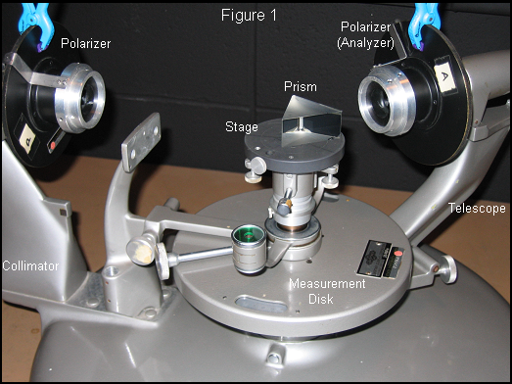
Figure 1. The spectrometer you will be using.

THEORY:
Fresnel’s equations are commonly given in the form
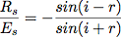 (1) 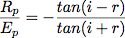 (2)
Where,
i = angle of incidence
r = angle of refraction
R_{s} = Reflected perpendicular component
R_{p} = Reflected parallel component
E_{s} = Incident perpendicular component
E_{p} = Incident parallel component

When the electric vector of the incident light is polarized at 45° (i.e., E_{s} = E_{p}) Eqs. (1) and (2) may combined such that
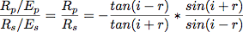
therefore,
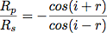 (3)
Thus, Eq. (3) tells us the ratio of the reflected electric vector’s components as a function of incident and refracted angles.
Let’s summarize. There are two kinds of angles to keep track of: angles defined by the position of the telescope relative to the collimator (i and r), and the polarization angles which lie in planes perpendicular to the plane of incidence. Eq. (3) relates the two kinds of angles. This is important to understand.
Eq. (3) will be the form of Fresnel’s equations that you will verify. From a terse observation it is apparent that to compute values for R_{p}/R_{s} you will need to know corresponding values of the refraction angle r and incidence angle i. The angle i will be obtained directly from the position of the telescope when trained on the reflected beam. The angle of refraction r will need to be obtained from Snell’s Law:

(4)
In order to complete our quest for the refraction angle we will now need to know the index of refraction n of the prism. This value may be obtained from the following expression.
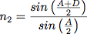 (5)
Where, A is the internal angle of the prism and D is the minimum deviation angle of the prism. The minimum deviation angle is a parameter of the prism and is shown in Figure 2. When an incident beam is refracted such that it travels parallel to a side of the prism, the angle created between the machine axis and this finally refracted beam is the angle of minimum deviation D. The machine axis is defined for convenience of measurement. It is a straight line traveling from the input light into the telescope when nothing has been placed on the stage. All measurements may be made relative to this axis.

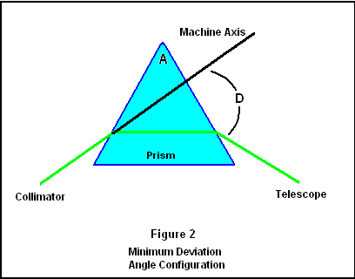
You will not only use the index of refraction in Snell’s law; you can also calculate the Brewster angle θ_{b}, as defined by
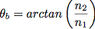 (6)
The Brewster angle is the angle of incidence where all reflections are completely p-polarized, and will thus serve as a good position for calibration, as you shall see later.

PROCEDURE:

In this experiment you will conduct the following:
- Alignment and calibration of the spectrometer and polarizers
- Measurement of the prism’s index of refraction
- Experimental verification of Fresnel’s equations (Eq. 3)

Alignment:
First, you should check the level of the base of the spectrometer. Do this by removing the stage (see Figure 1) and placing a bubble level onto the central post. Now adjust the leg screws as necessary. Replace the stage and level it accordingly. Make sure to rotate the bubble level while on the stage and the post.
Next the collimator and telescope (Figure 1) need to be leveled and focused. You will do this by using a collimated target that is not connected to the spectrometer. This target is fully collimated when viewed through the lens attached to it. Measure the height of the ends of the target to ensure that it is level. Adjust the tilt and focus of the telescope until the target is crisp and centered on the telescope’s crosshairs. Therefore, when you focus the telescope to it you are ensuring that the tilt and focus of the scope are correct. Now, using the mercury vapor lamp as a source, train the newly aligned telescope onto the collimator. By adjusting the tilt and focus of the collimator you should achieve a good image of the mercury vapor source.

Index of Refraction:
Before testing Fresnel’s equations you will need to determine the prism’s index of refraction. First, establish a machine axis by looking straight across the stage while it is empty. This will allow you to set the measurement disk at an easy point of reference.
Place the prism onto stage and rotate the telescope to closely approximate the configuration in Fig. 2. Observe the refracted image through the telescope. Begin slowly rotating the stage. You will have to follow the image with the telescope. When you have reached the minimum deviation angle D the refracted image will cease moving and begin to return back in the opposite direction, even though you have not changed the direction of the stage’s rotation. The minimum deviation angle is located at the cusp where the image changes direction. Repeat this procedure to arrive at an average value for n₂ (that of the prism) from [Eq. (5)], and be sure to associate the appropriate error in this measurement and calculation. Using your average value for n₂ and its error, calculate Brewster’s angle and its error. Be sure to use an appropriately accurate value for the index of refraction of air.

Polarization by Scattering of Light:
You are now ready to study Fresnel’s equations, and to measure Brewster’s angle with reflected light. You will do this by finding the reflected light’s polarization φ angle at various angles of incidence i. Replace the polarizer onto the telescope, we will refer to this polarizer as “the analyzer.” You must now create the conditions such that Eq. (3) is true, i.e. E_{s} = E_{p}. To do this you must first align the analyzer with the plane of incidence.
Observe a reflection from the prism with the incident light at the Brewster angle, Eq. (6). Adjust the polarizer so that extinction of the image corresponds to 0º (If you have aligned everything correctly this will leave the zero on the analyzer pointing straight up). The analyzer is now aligned with the s-component of the reflected E field, which does not exist at the Brewster angle. You have calibrated the analyzer to be perpendicular to the plane of incidence so that all future measurements of the polarization angle φ will be relative to this position. Now, remove the prism and rotate the telescope so that you are looking directly into the collimator (180°), this establishes a machine axis; set the scale accordingly.
You will now make E_{s} equal to E_{p}. Set the analyzer to 45º from the calibrated position (0°); you should still be able to see the slit. Attach the second polarizer to the end of the collimator and rotate it until extinction occurs. (Fix the collimator’s polarizer with a small clamp for the remainder of the experiment so that it does not waver.) The s and p components of the electric vector are now equal, and Eq. (3) is now valid.
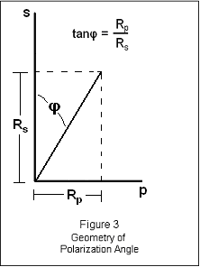
For each value of the incidence angle i Eq. (3) will provide you with a theoretical value for R_{p}/R_{s}. For a range of incident angles you will experimentally determine R_{p}/R_{s} by rotating the analyzer until extinction occurs and then recording this angle φ relative to your calibration. This extinction will occur for a range of φ, you should attempt to locate the center of this range. φ represents the orientation of the resultant vector from the addition of the s and p component of the reflected E field. Therefore the tangent of this angle represents R_{p}/R_{s}, see Figure 3 for clarification. This is extremely important to understand.
Plot your experimentally derived values for R_{p}/R_{s} vs. i with error bars. Show that this correlates significantly to the behavior predicted by Eq. (3). Report the index of refraction that you determined along with the Brewster angle for this prism.

