THE MICHELSON INTERFEROMETER
Last Revision: July 3, 2007

Question to be investigated:
How can the wavelength of a light source be accurately measured?

Introduction:
Interferometry is a technique used to investigate optical phenomena through the creation of interference patterns (hence, “interferometer”). Interferometers come in many shapes and sizes all of which, in some way or another, split a light source and then recombine it at the output of the device. Depending on the arrangement of various beam splitters and mirrors, the optical paths of the split beams can be drastically different, and therefore their recombination may result in an interference pattern. We will be using an arrangement commonly referred to as a Michelson Interferometer (Figure 1).
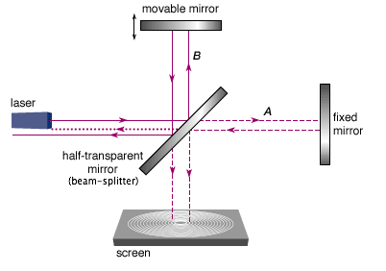
Figure 1. Behold, the Michelson Interferometer. When the movable mirror is translated either towards or away from the beam-splitter the optical path of light on this path is changed relative to light on path A.

You will use this device to calculate the wavelength of a laser source, as well as the indices of refraction of CO₂ and air.
Figure 1 depicts the astonishingly simple design of the Michelson interferometer. When light from the laser encounters the beam splitter it is divided in half. Half of the light is sent along path B towards the movable mirror and the other half is sent down path A towards a fixed mirror. The light then returns from each mirror and is recombined at the output and viewed on a screen. If the path lengths of A and B are different the light waves will be at different phases when they are recombined. The addition of these two waves will give an interference pattern (fringes) dependent on the difference in path lengths.

In the Michelson Interferometer the only path length that may be varied is that associated with path B. On the specific device you will use there is a screw and lever assembly attached to the rear of the mirror at the end of path B. This allows the mirror to be translated, thus increasing or decreasing path length. The screw is connected to the mirror by a lever that theoretically reduces translations of the screw by a factor of 5. However, this lever is connected through an angle, and the reduction factor is not always the same for macroscopically different angles. Is this a source of significant error that should be addressed? You should provide experimental evidence for your answer.

There is another way to change the effective length of path B: by changing the medium through which the light travels. You will do this by evacuating a small chamber along path B. When the chamber is fully evacuated the light travels faster than when it is full of matter. Thus by adding gas back into the chamber the path length will be increased proportionally to the pressure in the chamber. You will see a series of fringes as gas leaves or re-enters the chamber.
Remember, both of these techniques are useful for creating interference fringes on the output of the device may be counted and related to changes in path length.

Theory: Translation
To see how we may find a relationship between the wavelength of the input light and the translation of the movable mirror we must discuss light in general. The amplitude A and intensity I of a wave are generally described as:

The amplitude is split at the beam splitter and travels the distance between the beam splitter and the mirrors twice (2kL₁) and then to the projection screen (L_{p}), yielding:

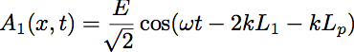
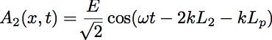

Where half of the energy travels along each path and their phases are described by the distances to the mirrors L_{1i} and the projection screen L_{p}. Through some algebra the superposition of these two waves describes the output of the interferometer as

(1)
Note the change from amplitude to intensity has left us with a cos² function. By substituting the standard definition of the wave number k into Eq. (1)
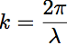

we can see that maxima and minima (fringes and extinctions) will occur when the following conditions are met:
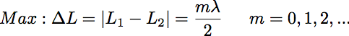

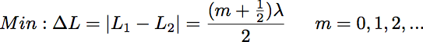

As you change the length of path B you will change the phase of the two beams relative to each other. When this translation corresponds to half of the wavelength (or, any integer multiple thereof) maxima will be seen in accordance to the cos² behavior of Eq. (1). Conversely, minima will be seen when the displacement causes the beams to be out of phase by 180º. Therefore, when path B is increased or decreased by a distance equal to a the wavelength of the light we should see an entire fringe/extinction event. Or, when the twice the translation equals the wavelength of the light:

and, therefore a train of N fringes will behave as

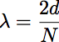
where N is the total number of fringes in the train seen during a translation of length d. However, the lever arm reduces translations by a factor of five. For our specific device lambda will be:
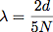 (2)
As previously mentioned, this factor of 5 varies with the macroscopic angle, and is not easily quantifiable. Therefore, as good physicists do, we would like to excise it from out calculations. This can be easily accomplished by finding the ratio of two wavelengths.

Theory: Index of Refraction
Instead of physically translating the mirror along path B a medium of higher index of refraction may also be introduced in order to increase optical path length. An evacuated cell has optical path length equal to its physical length t (light travels at c in a vacuum). A cell filled with a medium of index of refraction n has path length L_{i} , as:

Therefore the increase ΔL_{i} in optical path length will be

The “2” is present because the beam passes through the chamber twice during its trip. This increase then corresponds to the 2d from Eq. 2; substitution yields:

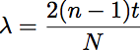

Thus, by counting fringes, and knowing the wavelength of the input light, the index of refraction n of any transparent material may be determined as

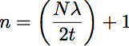 (3)
Experiment:
A. Introduction
Using this experimental apparatus will allow you to measure:
- The ratio of the red and green lasers’ wavelengths
- The index of refraction of air
- The index of refraction of CO₂
Report these values, their errors, and your results from investigating the lever assembly.

Turn on the input laser and dim the lights. You should see a diffraction pattern with concentric rings of fringes (or portions of rings) much like Figure 2.
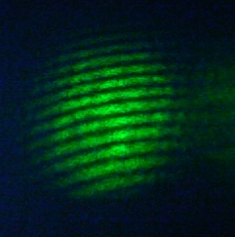
Figure 2: Overlapped light from paths A and B. Notice the regular pattern of fringes. This picture is intentional misaligned so that a large train of fringes may be counted.

As with any optics apparatus, alignment is fickle and attained only through vigilance. If you do not see an image like the one in Figure 2 you must now align your device. Do this by adjusting the screws attached to the rear of the fixed mirror.
B. Wavelength of the Laser Light
By utilizing the result in Eq. (2) we can see that we must count the number of fringes N for a given translation d. Translation of the mirror at the end of path B has been automated through the use of LabVIEW. The interface is pictured and described in Figure 3:
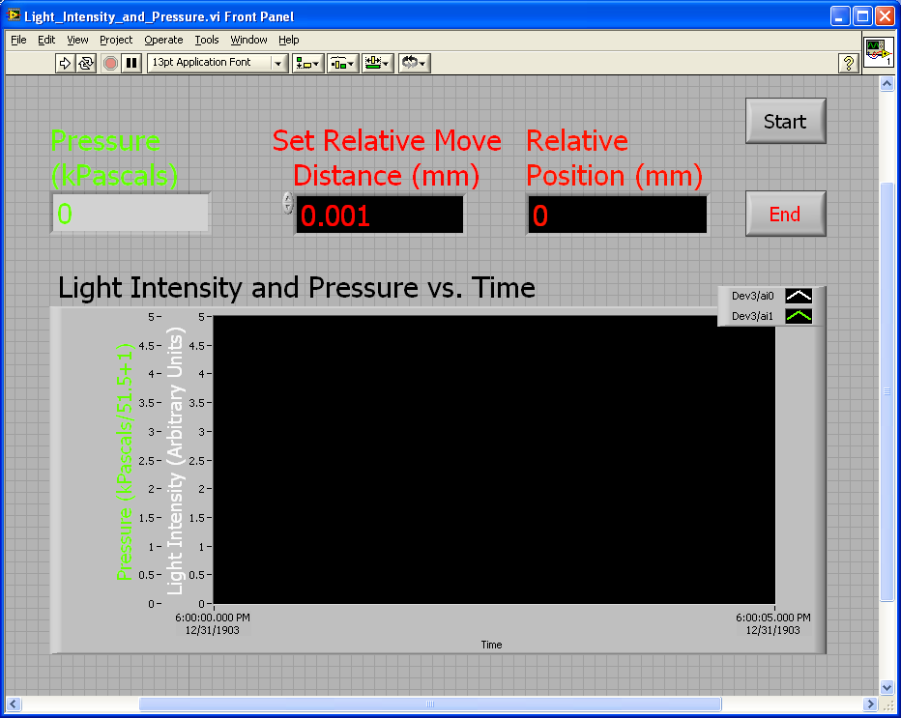
Figure 3: The LabVIEW interface for this experiment (filename “Light_Intensity_and_Pressure.vi”) This will automatically record relative motion, light intensity, and pressure. You can adjust the distance that it moves through, but not how quickly it will do so.

You will first want to set the starting position of the mirror, as the screw moves very slowly while collecting data. The LabVIEW program Set_Initial_Position.vi will allow you to set your mirror at a reasonable starting position from the zero or “home” value. A starting position of 8 mm is nearly ideal, but you may need to adjust this.
The two data-collection programs, Light_Intensity.vi and Light_Intensity_and_Pressure.vi, will both report relative intensity versus position, while slowly moving the mirror through a specified relative displacement. The resulting data can be opened directly be Excel and the relevant computations performed. You will need to determine a reasonable means of determining the number of fringes. Please note that the mirror will have a velocity of roughly .002 mm per second. Arrange for an appropriate distance with this in mind.

C. Index of Refraction of a Gas
You will now determine the index of refraction of both air and CO₂. As described in the theory section above, you will evacuate a small chamber along path B and fill it with a gas of interest. You will observe how many fringes pass as gas re-enters the chamber. You will be able to monitor the pressure on a digital pressuremeter. Figure 4 is a block diagram of the vacuum pump-tube assembly.
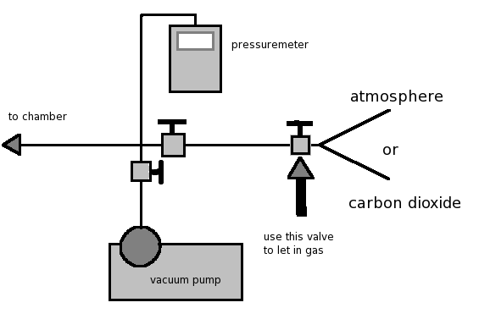
Figure 4: The vacuum pump assembly. The pressuremeter cannot be closed off from the chamber, and therefore always measures the chamber’s pressure. After evacuating the chamber close the pump’s valve and turn off the pump. Use the small thumb valve to allow air or CO₂ to re-enter.

Evacuate the chamber and then close the valve leading to the vacuum pump itself. Begin to slowly let air or CO₂ into the chamber while counting the fringes that pass. When measuring air, disconnect the tube from the large CO₂ tank to allow air to enter the system. There is a small thumb valve on the end of this tube (Marked with an arrow in Figure 4) that you should use to slowly allow gas to re-enter the system. Make sure that this valve is closed when evacuating the system or else the vacuum pump may begin to pump CO₂ into the room.

ATTENTION:
When preparing to use the large CO₂ tank consult your professor or TA for instructions. A large CO₂ spill in a closed room can cause oxygen deprivation and brain damage or death.

Record pairs of values for the change in pressure and number of fringes counted. Are these two variables related linearly? Prove it. Take as many data sets as necessary to obtain a statistically satisfactory fit. Use your fit to extrapolate for the number of fringes that would be counted with a pressure change back up to atmospheric pressure.

Note: The dimension t, which appears in Eq. (3), is the length of the vacuum chamber, which is precisely 5.00 cm for this device.

