PUMPED Nd:YAG LASER
Last Revision: August 21, 2007

QUESTION TO BE INVESTIGATED:
How can an efficient atomic transition laser be constructed and characterized?

INTRODUCTION:
This lab exercise will allow you to explore the characteristics of a solid-state laser system. This system consists of a resonator built around a Neodymium doped Yttrium Aluminum Garnet (Nd:YAG) crystal, which is in turn pumped by a diode laser. The diode laser, henceforth referred to as “the pump,” fires photons into the Nd:YAG crystal. If tuned correctly, this radiation can produce a population inversion in the energy levels of the crystal’s electrons. Stimulated emission may then take place. The resonating cavity significantly increases the occurrence of stimulated emission and must be precisely tuned so that most of the emitted radiation develops into a single standing optical wave. One of the cavity mirrors is partially transmitting such that some of the light can escape. The energy that leaks from the cavity, the output of the laser, is highly coherent and nearly monochromatic. It is from this behavior that the word “laser” originates; which is an acronym for “Light Amplified by Stimulated Emission of Radiation.”
Your principal charge is to create a reasonably efficient laser from this system; in other words, a laser that gives you as much output power as possible. To do this you will need to quantify the interaction between the pump light and the Nd:YAG crystal, as well as know how to control the wavelength of the pump. Finally, you will need to properly align the laser cavity to help achieve efficient amplification.

THEORY:
There are two lasers associated with this lab exercise, the pump and that based on the emission from the Nd:YAG crystal. The pump laser is a diode laser. The diode itself is in the same family as the common light-emitting diode (LED) component used extensively in modern electronics. In a diode laser, radiation is released from an electron-hole recombination that occurs across a p-n junction. This transition emits photons that are at a wavelength determined by the band gap of the semiconductor. The range of these wavelengths is wide in comparison to atomic transitions and is dependent on the doping technique used. Therefore, the intensity and wavelength seen at the output of the laser is controlled by the geometry of the resonance chamber. As you will see later in this experiment, the tuning of the YAG’s resonating chamber strongly affects the intensity of the laser. In the same fashion, to change the intensity and frequency of the pump you must manipulate its resonance chamber. This may be accomplished by controlling the current through the diode (injector current) and temperature of the mount.
The second laser in this system is that created from the photons emitted by spontaneous emission of the Nd:YAG crystal’s electrons. A population inversion must be created using the pump such that stimulated emission may take place more frequently than absorption. This is achieved via a four-level structure, which is illustrated in Figure 1. Stimulated emission occurs when an electron is made to transition from a higher energy level to lower level by the presence of a photon of equal energy to the transition. This transition emits a photon of equal energy, polarization, phase, and direction as the inducing photon. It is in this way that a laser acts a light amplifier.
The key to understanding how the four-level structure creates a population inversion lies in knowing the average time an electron will remain at any given level. In a standard four-level system, electrons do not stay in levels 2 or 4 for very long compared to the time spent at level 3. As the pump excites electrons from level 1 to 2, they are dumped into level 3. It is the stimulated transition from level 3 to 4 that emits the lasing photon. The transition from level 4 back to 1 is fast and thus returns electrons to their ground state to be re-pumped.

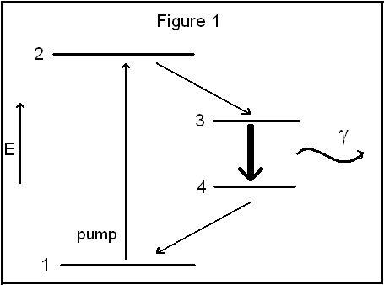
Under conditions where the transition from level 1 to 2 is not being driven, the electrons will obey the Boltzmann distribution, which implies that the lowest level should be the most populated. It is the pump’s job to supply photons of the correct energy to excite electrons from level 1 → 2, which,
Figure 1. Energy diagram of 4 Level system
consequently, populates level 3. This is an inverted population, and is aptly named, as under the correct pumping conditions, level 3 is more populated than the lower energy level 4.
A photon of energy 3 → 4 will stimulate other electrons in level 3 to transition to 4 thus emitting a similar photon. See Melissinos & Napolitano §4.1 for a mathematical treatment of stimulated emission.
All lasers contain some form of resonance chamber whose role is to dramatically increase the density of photons of energy 3 → 4. In this setup, you will use two mirrors. One mirror is placed down-steam from the YAG crystal and the other is a special coating on the aft end of the crystal’s mount. These mirrors trap the YAG’s emitted photons, thus promoting stimulated emission.
The efficiency of the resonance chamber is aided by the use of the four-level system. When the lasing photons are emitted and reflected back to the crystal they have a finite probability of being reabsorbed. This probability is significantly decreased by the fast transition 4 → 1. The reflected 3 → 4 photons are no longer of the correct energy to be absorbed by the electrons which have left level 4, and are thus reflected by the crystal’s mirror.
Lasers also contain many components that are common to the field of optics (optics track, lenses, etc…). Take a look at Figures A & B, if you are not familiar with these components it is suggested that you become so before constructing the pumped laser.

EXPERIMENT:

!! THIS EXPERIMENT UTILIZES A
CLASS IV LASER. SAFETY GLASSES
MUST BE WORN WHILE THE LASER
IS IN OPERATION !!

As stated above you have one goal: Create a pumped Nd:YAG laser with reasonable efficiency. You must keep in mind that no system can attain 100% efficiency and your laser will most likely be far from it. However, efficiencies on the order of 20% are not uncommon. To achieve this goal you must first understand the how the temperature of the diode laser and the current driving it affect the wavelength of light that it emits. You will also want to know how the YAG crystal’s absorption depends on frequency so that you can tune the pump laser to the maximum absorption frequency.
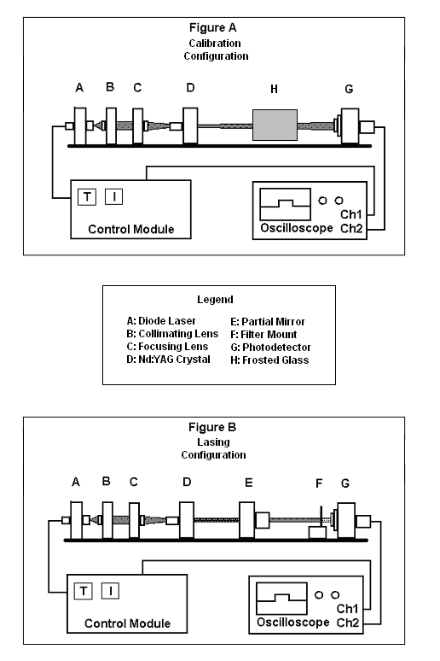.
Figures A & B. Configurations for the optics table relevant to this experiment.

Preliminary Calibration of the Pump:
Begin by first probing the behavior of the diode laser itself. Its behavior can be described by the following function:
λ = A + BT + CI (1)

Where T is the temperature of the diode, I is the injector current, and λ is the wavelength of the diode laser’s output. Both T and I can be manipulated through the control box. A, B, & C are constants that should be experimentally determined.
You have at your disposal all of the components depicted in Figures A & B. The photodetector (G) is connected to a computer-based oscilloscope (Softscope). Make sure that one trace is devoted to the output of the photodetector, and the other is monitoring the signal driving the diode laser (injector current). The injector current should be set to be internally triggered (the “int.” setting on the control box); this will allow for easy oscilloscope triggering. The injector current will therefore be a repeating waveform to be observed on the oscilloscope. The signal from the photodetector (G) will vary in magnitude with the intensity of the light incident upon it.
You will use a spectrometer to measure the wavelength of the diode laser. The spectrometer, manufactured by the OceanOptics company, communicates with the computer to convey a real-time display of what it sees. This display will be in the form of a graph depicting counts vs. wavelength. This device is very sensitive, and should never be placed directly into the laser beam. Instead, a flat piece of frosted glass should be placed in between the YAG crystal and the photodetector (See Figure A). The beam should pass through the length of the glass into the photodetector. The fiber optic cable from the spectrometer should be trained on the wide face of the glass that is perpendicular to plane of the optics table. This will sufficiently decrease the intensity of the beam while allowing you to measure its wavelength (OceanOptics) and absorption (Softscope) simultaneously. More specifically, as the laser fires into the crystal some of its energy will be transmitted directly to the photodetector. By observing how this transmitted energy behaves with temperature and current, via the oscilloscope and spectrometer, you will be able to construct curves of “Absorption vs. T” and “Absorption vs. I” yielding the coefficients in Equation 1. You will also be able to tell the wavelength of the light at an time using the spectrometer.
You will also want to take “background” for each of these curves. To take this data you will perform a temperature and current scan without the YAG crystal present. Then subtract this data from the data taken with the YAG to assure cancellation of any effects inherent to the photodetector.
As you will immediately notice, the pointer in the Ocean Optics program does not have a small enough step to accurately locate the observed peak. You should, therefore, save this data so that you may fit a Gaussian to it. To get good data you should set the Ocean Optics program to average inputs as many times as possible. This will allow you to correlate values of temperature and current to the corresponding values of the diode laser’s wavelength.
Simultaneously you will use Softscope to probe the absorption characteristics of the Nd:YAG crystal. Use the amplitude measurement utility (“Util” menu) to observe the intensity of the transmitted beam. To stabilize this value you should set Softscope to average its input as well (“Acquire” menu).

Laser Construction:
Now that you have identified the energy at which the Nd:YAG crystal most absorbs, and how to assure that the diode laser is emitting there, the time has come to construct the pumped laser. This configuration is shown in Figure B. There are only a few differences between Figures A & B, the partially reflecting mirror (E) and the filter mount (F). The partially reflecting mirror is just that, some incident photons will be reflected, (thus constructing the resonance chamber) and some will be emitted as the laser output. The other added component is a filter. This filter, which is labeled “RG 1000”, will block out the radiation emitted by the diode laser allowing you to see only the emission of the crystal. You should also remove the frosted glass when attempting to achieve maximum lasing.
You should now fire upon the crystal with full power and at the frequency which is most absorbed by the Nd:YAG crystal. The efficiency of the laser is highly dependent on the alignment of all of the optical components and will require many fine adjustments in order to see maximum output. Small variations in the distances between the components will produce large changes in output. This variation in output can be easily seen by translating the output coupler (another term for component E) back and forth while watching the oscilloscope trace. However, moving most of the components will result in this variation as well.
You should use a power meter to quantify the efficiency of your new laser. Provide a screen shot of the oscilloscope when it is tracing your maximum lasing signal.
Report the following:
- Values for the coefficients in Eq. (1) and their errors.
- Graphs of Absorption vs. T and Absorption vs. I corrected for background.
- The frequency at which the YAG crystal most highly aborbs.
- A waveform of the maximum lazing observed.
- An estimate of the efficiency of your new laser with error.

REFERENCES:
Hollberg & Wieman. Using Diode Lasers for Atomic Physics. Review
Of Scientific Instruments 62 (1), January 1991.
Melissinos & Napolitano. Experiments in Modern Physics. 2nd Ed.
Academic Press, 2003. Chapter 4.
Rex & Thornton. Modern Physics. 2nd Ed. Brooks/Cole: Thomson
Learning, 2002. pp 361-363.

