THE DIFFERENTIAL CROSS SECTION
FOR COMPTON SCATTERING

DISCUSSION

The theoretical scattering cross-section for the Compton Interaction can be written (see Refs. 2 and 3):
(12)
where
and

Figure 9.7 shows Eγ' at θ = 60 degrees. At larger angles Eγ' decreases in accordance with Eq. (10). At 130 degrees Eγ' would be 211 keV. The values of (Σ-β) recorded in Table 9.1 have to be corrected for the intrinsic peak efficiency of the detector. The corrected sum is given by:
(13)
where εp is the intrinsic peak efficiency for Eγ'.

Figure 9.7. Nal(T) pulse height spectrum of Compton scattered gammas at θ = 60 degrees from 137Cs. (Note: At θ = 0 degrees, the scattered peak would have the full energy of the 137Cs source 662 keV.)

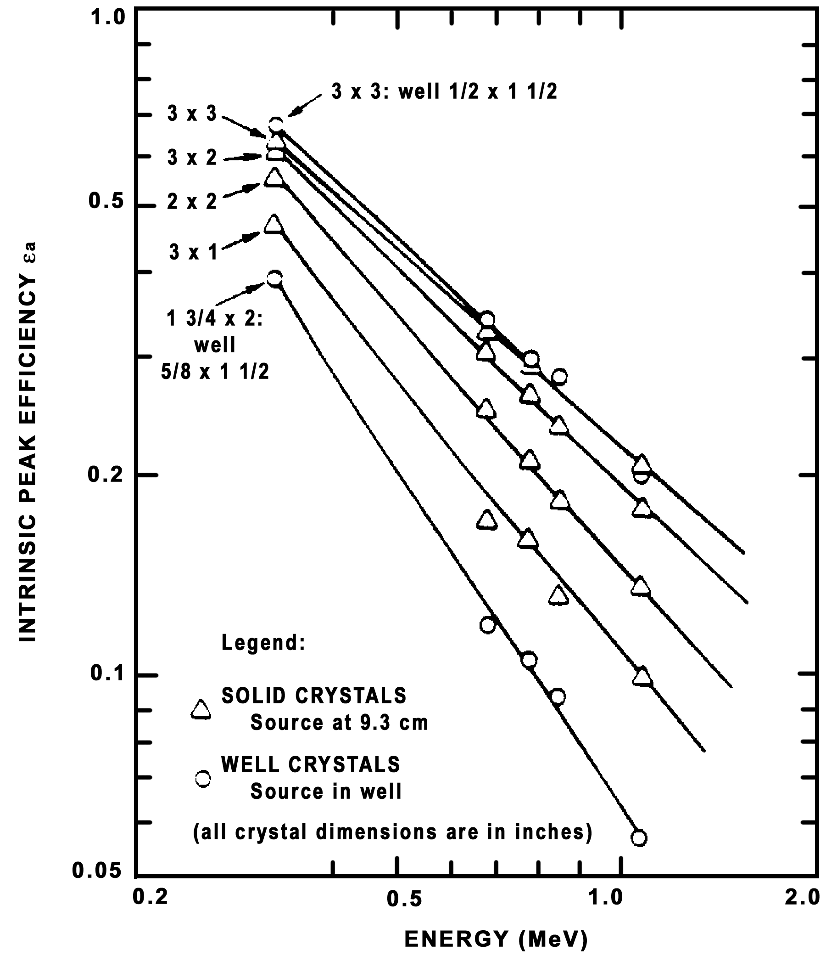

Figure 2.14. Intrinsic peak efficiency (εa) for a wide variety of Nal(T) crystals. The source to detector distance is 9.3 cm (Courtesy of Idaho Operations Office DOE).

For example, the (Σ-β) shown in Figure 9.7 would be divided by the appropriate εp for an energy of 401 keV. The measured Compton cross section is then given by:
(14)
where
(15)

(16)

(17)
NOTE: in Eq. (15), the volume of the aluminum scatterer is given by:
(18)
where

Ro = .635 cm

h = R1 sin φ1 (see Figure 9.4)

φ1 = 3.58 degrees

From your experimental data (Σ-β/t) in Table 9.1 calculate (dσ/dΩ)measure Eq. (14). Enter these experimental points on the theoretical curve 9.6 as shown in the figure. The results should show that the Klein-Nishina theory [Eq. (12)] does a good job of predicting the scattered Compton differential cross section.

References

1. W. Heitler, The Quantum Theory of Radiation, 3rd ed., Oxford Univ. Press, 1957.

2. R. D. Evans, The Atomic Nucleus, McGraw-Hill, New York, 1955, pp. 674–676.

3. A. C. Melissinos, Experiments in Modern Physics, Academic Press, New York, 1966.

4. G. F. Knoll, Radiation Detection and Measurement, John Wiley and Sons, New York, 1979.

5. P. Quittner, Gamma Ray Spectroscopy, Halsted Press, New York, 1972.

6. R. L. Heath, "Scintillation Spectrometry," Gamma-Ray Spectrum Catalog, 2nd Edition 1 and 2, IDO 16880, August, 1964. Available from Clearinghouse for Federal Scientific and Technical Information, Springfield, Virginia.

7. C. M. Lederer and V. S. Shirley, eds., Table of Isotopes, 7th Edition, John Wiley and Sons, New York, 1978.

8. K. Siegbahn, ed., Alpha-, Beta-, and Gamma-Ray Spectroscopy, 1, North Holland Publishing Co., Amsterdam, 1965.

9. A. W. Mann and S. Garfinkel, Radioactivity and its Measurement, Van Nostrand-Reinhold, New York, 1966.

10. J. B. Marion and P. C. Young, Tables of Nuclear Reaction Graphs, John Wiley, New York, 1968.

Figure 9.6. Theoretical Compton scattering cross section vs. angle.

Equipment and Supplies
• Computer with PCA board for MCA emulation
• HV power supply (240 regulated HV supply)
• Amplifier (Canberra model 816 or equivalent)
• HV cable with SHV connectors
• BNC cables
• NIM bin
• Oscilloscope
• NaI(Tl) scintillator with PMT and bleeder string
• Plenty of lead bricks to block source
• Strong Cesium 137 source

